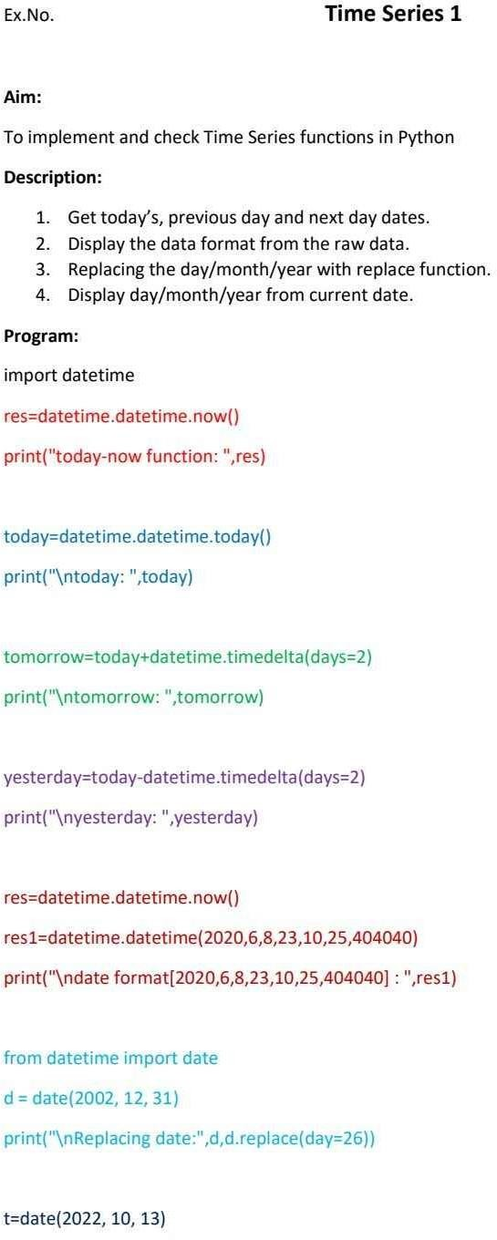

**Ex.No-8**

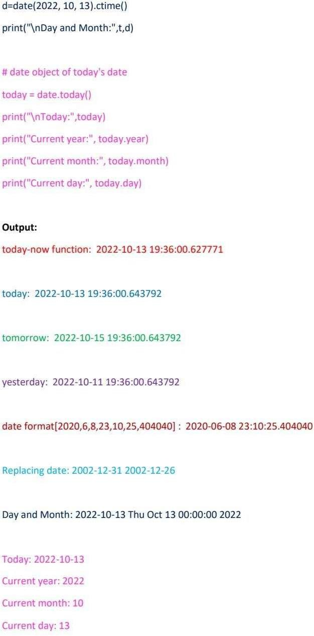

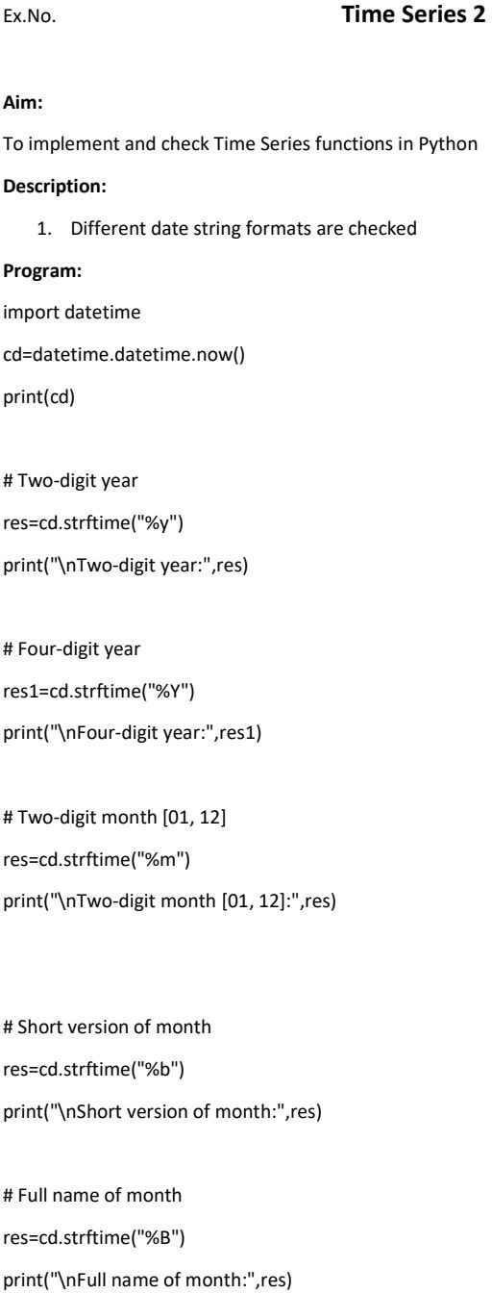

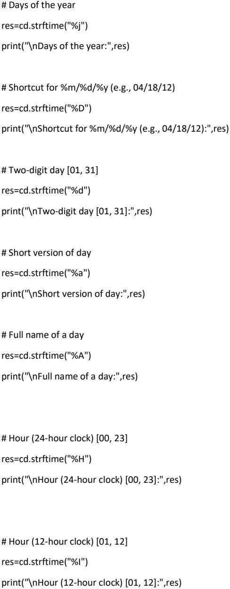

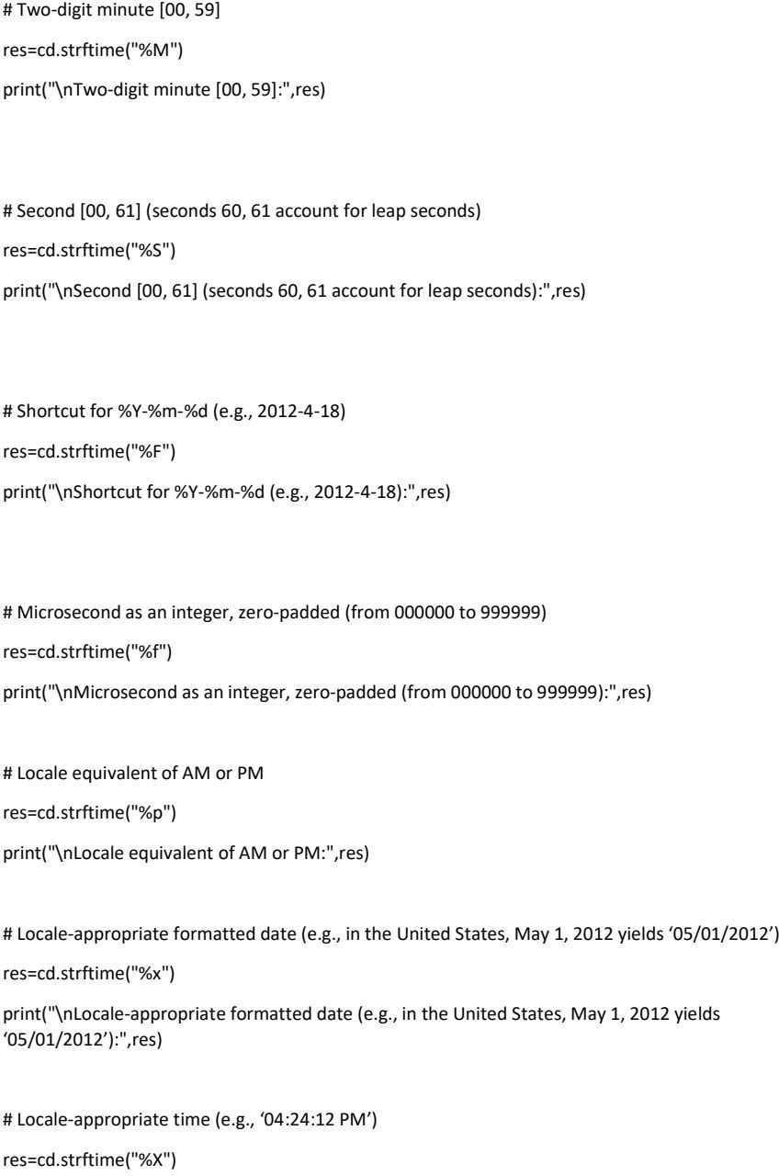

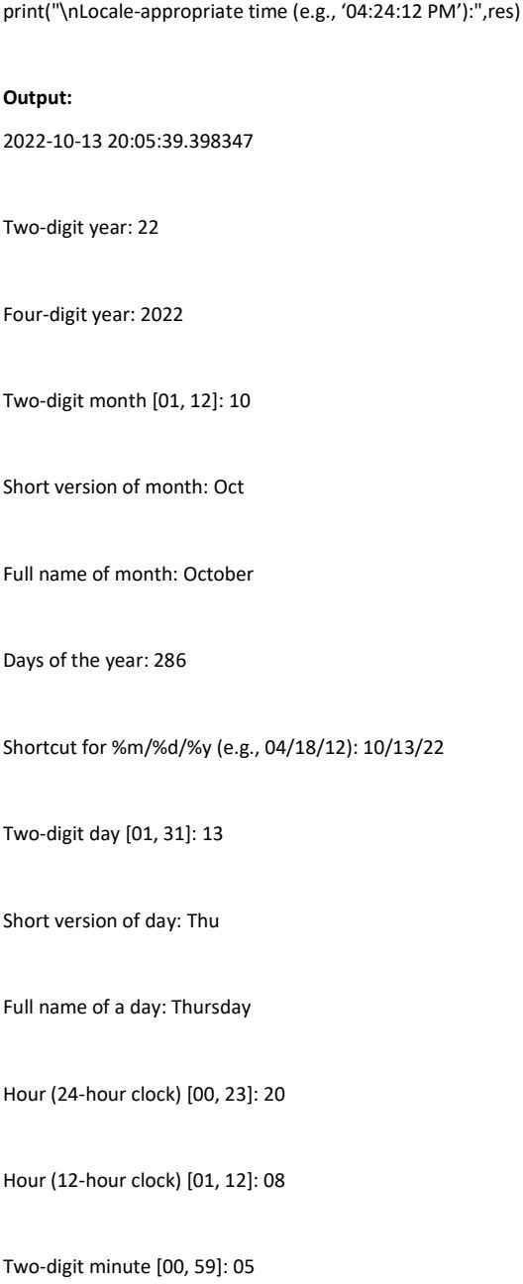

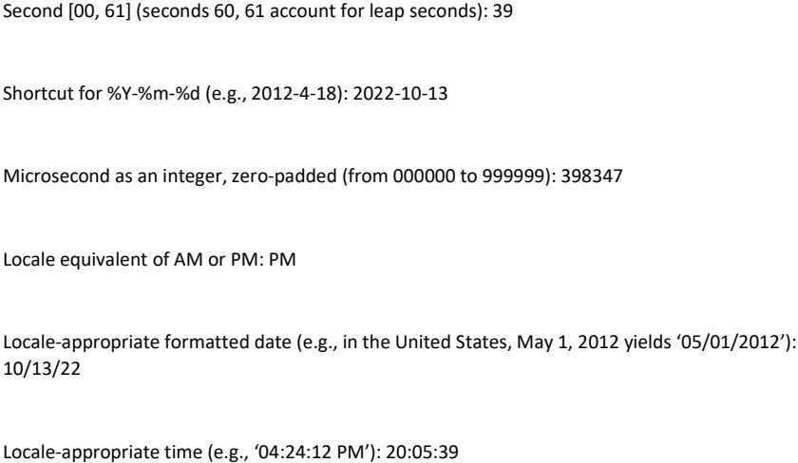

# Time Series -3

**Aim:**

To implement and check Time Series functions in Python.

# Description :

Implements different date time functions through DataFrame using CSV

# Program :

import pandas as pd import datetime

import matplotlib.pyplot as plt df = pd.read_csv("Datas.csv")

print("Original Dataframe:\n",df) xpoints = df["Dates"]

ypoints = df["Experiment"] plt.plot(xpoints,ypoints) plt.show()

# Output :

Original Dataframe:

Dates Experiment

1. 22-02-2024 Data loading and storing
2. 29-02-2024 Data wrangling
3. 14-03-2024 Data cleaning
4. 21-03-2024 Time series

4 28-04-2024 KNN

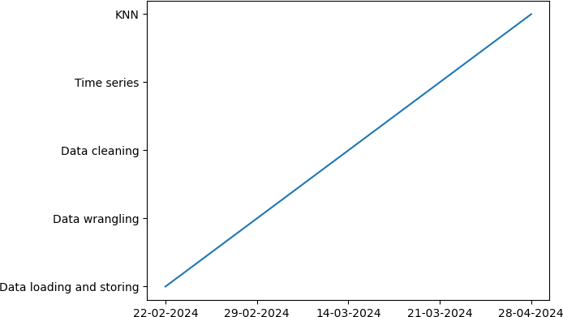

# Result:

Hence the programs were run successfully.